Wells College

[Company name]  [Company address]

**Contribute to organizational privacy and contingency plans**

|  |  |  |  |
| --- | --- | --- | --- |
| Name of Student |  | ID |  |

# Assessment 2- Research

#### Instructions

This is an in-class closed book written assessment. Answer all the questions on the paper provided by your Trainer.

Contents

Assessment 2- Research 1

Duration: 1

Task 1-Multiple choice Questions: 2

Index 10

### Duration:

Trainer will set the duration of the assessment.

### Image result for intellectual property rightsTask 1-Multiple choice Questions:

1. Intellectual Property Rights (IPR) protect the use of information and ideas that are of
   1. Ethical value
   2. Moral value
   3. Social value
   4. Commercial value

Refer: <https://www.ipaustralia.gov.au/understanding-ip>

Intellectual property (IP) is the property of your mind or proprietary knowledge. Basically, the productive new ideas you create. It can be an invention, trade mark, design, brand, or the application of your idea.

Comment: it is important commercial value to help your business.

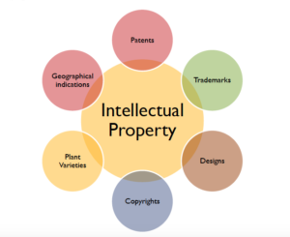

1. The term ‘Intellectual Property Rights’ covers
   1. Copyrights
   2. Know-how
   3. Trade dress
   4. All of the above

Intellectual property rights are the rights given to persons over the creations of their minds. They usually give the creator an exclusive right over the **use** of his/her creation for a certain period of time.

Refer: <https://www.wto.org/english/tratop_e/trips_e/intel1_e.htm>

Comment: IT could help the people make more new creation and contribute more for society.

1. The following cannot be exploited by assigning or by licensing the rights to others.
   1. Patents
   2. Designs
   3. Trademark
   4. All of the above

Refer text book: Intellectual property includes copyright of publicly available material, but also extends to less tangible assets and knowledge, such as patents, trademarks, designs, trade secrets and ‘know-how’.

Comment:

If you want to protect your business name, brand names, logo or catchphrases from being used by others, you need to register a trade mark. Best protect your business is using Trademark

Please refer: <https://sprintlaw.com.au/lp/register-your-trade-mark/>

1. The following can be patented
   1. 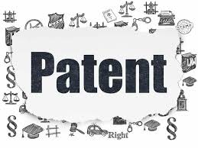Machine
   2. Process
   3. Composition of matter
   4. All of the above

Refer: <https://en.wikipedia.org/wiki/Machine_(patent)>

Comment: machine and composition of matter are patented. Process could be thought is part of patented. So the best answer is d.

1. 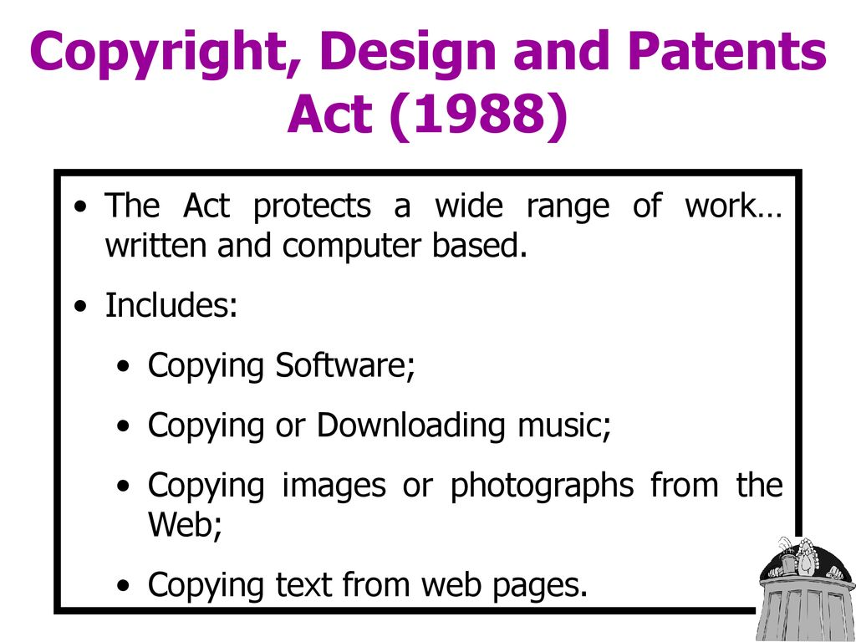Which of these rights isn't generally regarded as part of designs law?
   1. Registered designs law
   2. Copyright
   3. Trade mark law
   4. Design Right under Part III of the CDPA (copyright, designs, patents act)

Comment: select a, b and d all under the CDPA, but trade mark law not part of designs law.

Refer: <https://en.wikipedia.org/wiki/Copyright,_Designs_and_Patents_Act_1988>

The Copyright, Designs and Patents Act 1988, also known as the CDPA, is an Act of the Parliament of the United Kingdom that received Royal Assent on 15 November 1988.

1. To enforce copyright to prevent a product from being copied:
   1. The claimant's product must be represented in an artistic work.
   2. Articles made to the design must have been marketed.
   3. The defendant's product must be a substantial copy of the claimant's product.
   4. The claimant's designer must have created the design for the claimant's product in the form of a drawing or a model that is an artistic work.
2. Copyright law protects:
   1. Tangible property.
   2. Intangible property.
   3. The name of a particular good or service.
   4. Ideas contained in varied forms of expression.
3. While sharing some similarities, committing plagiarism and violating copyright are different because plagiarism involves:
   1. Using someone else's work as if it were your own.
   2. Distributing someone else's work.
   3. Reproducing someone else's work.
   4. All of the above.
4. The exclusive rights that apply to copyright owners include the right of:
   1. Public distribution of the work.
   2. Reproduction of the work.
   3. Preparation of derivative works.
   4. All of the above.
5. Before a copyrighted work like a book may be printed:
   1. The book must be registered with the Copyright Office.
   2. Consent of the copyright owner must be obtained.
   3. The copyright symbol must be affixed to the book.
   4. None of the above.
6. Excluding "work for hires," a sole-authored original work created after 1978 receives copyright protection for:
   1. 56 years.
   2. 95 years.
   3. 67 years.
   4. The life of the creator plus 70 years.
7. The Digital Millennium Copyright Act (DMCA):
   1. Provides exemptions from copyright infringement claims to Internet service providers (ISPs) who are merely acting as conduits.
   2. Establishes compulsory licensing for the transmission of music over the Internet.
   3. Prevents the circumvention of technological measures designed to protect copyrighted works.
   4. All of the above.
8. Basil is a designer who works for Meteor Motors Ltd, a company which manufactures specialist sports cars which are built on a timber frame. For a forthcoming press release about a new model of car (the Meteor Merlin), Basil made a three-dimensional space-frame replicating the new revolutionary timber frame to be used for the Merlin. He built it from engineering drawings using balsa wood (a very lightweight wood which possesses little strength but is useful for modelling) with glued joints. The real cars will be built using a strong ash frame with sturdy bolted joints. Which one of the following best describes Basil's balsa wood and glue space-frame from a copyright perspective?
   1. It is not protected by copyright as copyright does not protect industrial designs
   2. It is not an artistic work on the basis of being a sculpture or a work of artistic craftsmanship.
   3. Anyone copying the space-frame will infringe the copyright in the drawings indirectly as these are protected irrespective of artistic quality
   4. As the space-frame will not be seen in normal use of the Merlin, being covered by metal panels and body parts, there can be no artistic copyright (which requires eye-appeal) in the frame nor in the drawings as these lack artistic quality, being engineering drawings
9. Roger is a computer programmer and is employed by a software development company known as Programmers R Us Ltd. A retail organisation known as Acme Trading Ltd asked Programmers R Us to write some computer software to handle Acme's accounts and paid Programmers R Us a fee of £87,500 for the work. All the work was carried out by Roger at Acme's premises and on Acme's computer during a period of 10 months. Roger was paid an hourly rate (£17.25 per hour) by Programmers R Us for his work on the project. There is nothing in writing to say who owns the copyright subsisting in the computer software and there is no written assignment of copyright. There is no express or implied agreement as between Roger and Programmers R Us as to copyright ownership. Which one of the following most accurately describes the position as regards ownership of copyright in the computer program?
   1. Roger owns the copyright at law and at equity as he created the software. Any presumption that his employer, Programmers R Us owns it is displaced because he created the software at Acme's premises and using Acme's equipment
   2. Acme Trading Ltd owns the legal and beneficial copyright in the software because it paid for it to be written, there was no agreement to the contrary and Programmers R Us owes a fiduciary duty to Acme
   3. As there was no formal assignment of copyright complying with the Copyright, Designs and Patents Act 1988, Programmers R Us is the first owner of the legal title to the copyright as Roger created the software as an employee in the course of his employment? However, a court is likely to hold that Acme is the beneficial owner of the copyright or at least has an implied licence to continue to use it
   4. Acme Trading and Programmers R Us are joint owners of the legal and beneficial copyright. This will enable Acme to continue to use the software and both Acme and Programmers R Us to licence the software to third parties
10. Naomi MacDonald is a poet who wrote a series of poems on the theme of 'The Four Seasons' for Limerick Publishing plc ('LPP'). Naomi granted LPP an exclusive licence to publish the poems as a collection in book form under the name 'The Four Seasons Poems'. There were no terms in the licence agreement relating to Naomi's moral rights. LPP published and sold the entire print run of 800 copies of the book with Naomi being acknowledged as the author on the cover and flyleaf.

However, LPP decided not to reprint the book and informed Naomi accordingly. Naomi subsequently assigned the copyright in her Four Seasons Poems to Epic Sagas Ltd ('ESL'). A term in the assignment stated that Naomi was to be identified as author under her newly adopted pseudonym 'Helena Campbell'. ESL duly printed copies of the poems and put them on sale. They bore the author's name as Naomi MacDonald as a result of an oversight by ESL's printing sub-contractor. Which one of the following statements is correct?

* 1. ESL is in breach of Naomi's right to be identified as author as she specified the pseudonym 'Helena Campbell' in the assignment and that form of identification only must be used
  2. Although there is potential liability for failing to use the specified form of identification, ESL is not liable as the mistake was that of its printing sub-contractor who will be liable to Naomi for its error
  3. As the book of poems was lawfully first published with the name Naomi MacDonald as author, this overrides any later assertion of the right to be identified as author
  4. There is no infringement of Naomi's right to be identified by author by ESL as using her real name to identify her is a reasonable form of identification

1. Frederick is a well-known commercial artist who is employed by Graphic Designs Ltd ('GDL'). As part of his employment duties, Frederick produced an original drawing depicting an angler fishing from a boat in the process of reeling in a large barracuda fish. The drawing captured the excitement of the event. Frederick's name did not appear on the drawing. GDL assigned the copyright in the drawing to Southern Sports Ltd ('SSL'), which applied copies of the drawing to T-Shirts, which were sold in large numbers to keen anglers. A charitable organisation, Campaign Against Cruel Sports ('CACS') started placing advertisements which include a copy of Frederick's drawing but with the head of the angler replaced by the head of a monstrous devil and to which a slogan had been added stating 'All anglers are sub-human fiends'. CACS did not have SSL's permission to copy or modify the drawing. Frederick was incensed when he saw CACS's advertisement. Which one of the following statements is correct?
   1. If Frederick sued CACS on the basis of the moral right to object to a derogatory treatment of his drawing, CACS would escape liability if it raised a defence based on freedom of expression under Article 10 of the Council of Europe Convention for the Protection of Human Rights and Fundamental Freedoms
   2. As Frederick does not own the copyright in the drawing he has no remedies under copyright law
   3. As Frederick's name does not appear on the drawing he cannot object to the treatment of the work as the right only applies if the author is identified as such on copies of the work
   4. Frederick has a right to object to a derogatory treatment of his work as the modification was not made by or with the authority of the copyright owner providing it amounted to a distortion or mutilation of his drawing or is otherwise prejudicial to his honour or reputation
2. In relation to infringement of an original work of copyright, which one of the following statements is not correct?
   1. Substantiality is more concerned with quality rather than quantity, in other words, it is the importance of the part taken to the work that has been copied which is the predominant question
   2. Copyright infringement requires, essentially, three things to be shown (i) that copyright subsists in the claimant's work, (ii) that the defendant has copied from the claimant's work (directly or indirectly), and (iii) that the part copied by the defendant is a substantial part of the claimant's work
   3. The part taken from the claimant's work must be a substantial part of that work but need not be a substantial part of the defendant's work
   4. Where an artistic work is copied by converting it from three-dimensions to two-dimensions, or vice versa, the copy must, in the eyes of a non-expert, look like the work copied
3. Privacy in Australia is overseen by:
   1. Australian Security Intelligence Organisation
   2. Australian Securities Commission
   3. The Privacy Commissioner
   4. The Privacy Ombudsman
4. The legislation which sets out the rules for privacy in Australia is called:
   1. The Official Secrets Act
   2. The Freedom of Information Act
   3. The Corporations Law
   4. The Privacy Act
5. The Privacy Act applies to whom?
   1. Government departments only
   2. Large corporations only
   3. Private enterprise only
   4. All of the above
6. The Privacy Act is concerned with how all personal information is used and stored. This statement is:
   1. True
   2. False
7. People have rights to access information a company or Government Department holds about them.
   1. True
   2. False
8. An organisation should only use or disclose a person's information for the purpose it was collected unless the person has consented to it being used in another way.
   1. True
   2. False
9. Define morality
   1. What is considered as correct within a society
   2. Making the right decision's where there is a chance to do wrong
   3. Defining what is right and wrong for an individual or a community
   4. Where individuals have a conscious choice to make a right and ethical decision
10. What is business ethics?
    1. The study of business situations, activities, and decisions where issues of right and wrong are addressed
    2. Defined as decisions organisations make on issues that could be considered right or wrong
    3. Ethics that can be applied to an organisation’s practises
    4. Ethical processes businesses use in order to achieve a good ethical standard
11. Which is not a reason a business engages in business ethics?
    1. To recover a company’s image after a notorious business scandal
    2. To avoid the loss of a good corporate image or being sued for misconduct
    3. To enhance global relationships
    4. To enhance stakeholder relationships
    5. To act with real commitment
    6. To build corporate reputation
12. Which one is a purpose of Privacy?
    1. protects individuals from misuse of their personal information
    2. protects the rights of owners of published and unpublished material
    3. ensures equal rights regardless of gender, ability, religion or ethnicity
    4. protects the good name and reputation of individuals and businesses
13. There are 10 National Privacy Principles. Which of the following is not the privacy principle?
    1. Organisations must give people the option to interact anonymously whenever it is lawful and practicable to do.
    2. Generally speaking, an organisation should not give an individual access to personal information it holds about that individual on request.
    3. An organisation must take reasonable steps to make sure that the personal information it collects, uses or discloses is accurate, complete and up-to date.
    4. An organisation must have a policy document outlining its information handling practices and make this available to anyone who asks.
14. What are the common security features covered in a system’s functional requirements?
    1. log ins
    2. password policies
    3. open public shells
    4. secure directories
    5. encryption protocols
15. IT support staff loudly discuss their organisation’s network security problem on a crowded train. This statement relate to which ethical issue.
    1. Reliability
    2. Security
    3. Confidentiality
    4. Proprietary rights
    5. Conflict of interest

### Index

B

business name 3

C

computer programmer 5

copyright 2, 3, 4, 5, 6, 7

I

Intellectual Property Rights 2

IT support 10

S

sub-contractor 6

T

trade mark 2, 3